Application Form of Audio Recorder Devices for NCHU Ambassador
Office of International Affairs, National Chung Hsing University
國立中興大學國際事務處 僑外生招生大使錄音設備借用申請表
Date of Application:
- Must register for NCHU Ambassador-Short Film and upload the film script to the system first.
須先報名僑外生招生大使-短影片並提供影片腳本。
- Applications including the film script must be emailed to the OIA administrator (Laurel, laurel@nchu.edu.tw)
3 days before the intended use.
須在使用前三天提出預約申請並將申請表及影片腳本email給國際處承辦人。
- Please check for any missing parts or damages before using. If any are found, notify the administrator for replacement. Otherwise, any damages found upon return will be considered as caused by the borrower and are subject to compensation.
外借器材請先確認是否缺件損壞，如有告知管理人員更換，否則歸還時視為借用人損壞須賠償。
- If it is discovered after use that the devices were not returned according to the regulations, or if the devices are damaged or lost, compensation for the damaged or lost equipment will be required.
借用完畢後若發現器材未依規定或損毀、遺失，須賠償所損壞遺失之器材。
Name 姓名 |  |  |  |  |  |  | Student ID學號
Program系級 |  |  |  |  |  |  | Phone No. 聯絡電話
Email
Date of Borrowing  借用日期 |  | Year | Month |  | Day |  | Time
 | From |  |  |  |  |  | : | Maximum: 7 days
 | To |  |  |  |  |  | :
Where will you use these devices?  使用地點 | □ On-campus (校內)  □ Off-campus (校外)/please specify：
Signature of the Borrower  借用人簽名 |  |  |  | - I have read and understood the instructions of the device and agree to comply with all the terms and conditions for borrowing recording devices.  - I understand that I have to prepare the following devices:  - Alkaline batteries  - Micro SDHC/SDXC Cards (See list)
Devices  外借錄音器材 | ZOOM F2-BT File Recorder 微型錄音機+領夾麥克風組(NT$7,560/set)  - Introduction  - Operational Manual (Important-Must Read Before Use)
Confirmation of OIA Administrator  承辦人檢核 | □Approved. Device Number: □60106-02 0000872 □60106-02 0000873  □Rejected/ reason: Signature：
Items |  |  |  |  |  | Borrow |  |  |  | Return
F2-BT File Recorder
LMF-2 Lavalier Mic + Mic Clip + Windscreen
Operational Manual & Safety Precautions
WaveLab Cast download access code sheet
Cubase LE/WaveLab Cast startup guide
Shell Case
□ Returned on schedule 如期歸還
□ Devices undamaged and complete 設備無損毀且齊全
□ Devices damaged器材損毀 □ Devices lost器材遺失
□ Not returned according to regulations, rights suspended 未依相關規定歸還，停權
Signature of the Borrower  借用人簽名 |  |  |  |  |  | Signature of  OIA Administrator  出借管理者簽名
Flowchart of Audio Recorder Devices for NCHU Ambassador
Office of International Affairs, National Chung Hsing University
國立中興大學國際事務處 僑外生招生大使錄音設備借用流程

Read more: https://oiawp.nchu.edu.tw/audio_recorder_devices_rental/
- Must register for Short Film upload the script
- 2024 Summer Ambassador
- typing is preferred
- Email the form to
laurel@dragon.nchu.edu.tw
- Introduction
- Operational Manual
Register
NCHU Ambassador
Email the form to OIA at least 3 days before date of borrowing
Wait for Reply/
Collect the device at OIA
Return on time
Read Manual before use

F2-BT File Recorder |  | LMF-2 Lavalier Mic  (with Mic Clip & Windscreen)
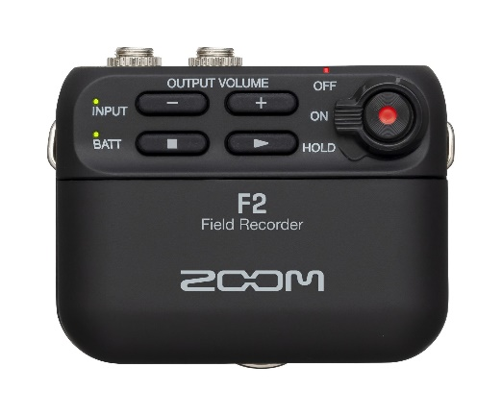 |  | 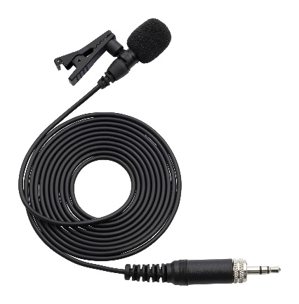
Operation Manual |  | Safety Precautions
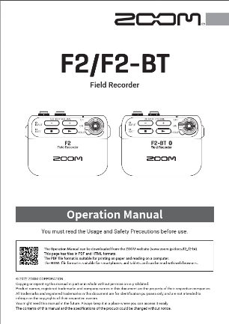 |  | 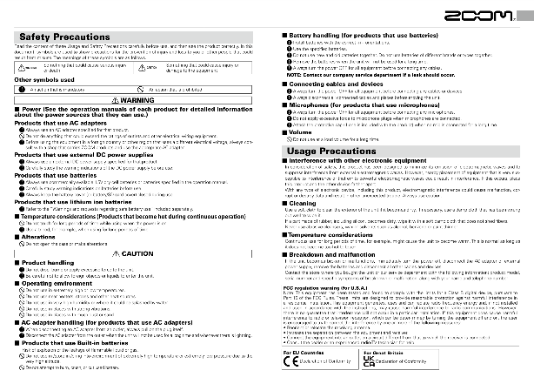
WaveLab Cast Download Access Code Sheet |  | Cubase LE/WaveLab Cast Startup Guide

